**DAILY ONLINE ACTIVITIES SUMMARY**

|  |  |  |  |  |  |  |  |  |
| --- | --- | --- | --- | --- | --- | --- | --- | --- |
| **Date:** | **06-06-2020** | | | | | **Name:** | **Ashwini** | |
| **Sem & Sec** | **A** | | | | | **USN:** | **4AL17CS017** | |
| **Online Test Summary** | | | | | | | | |
| **Subject** | | **OR** | | | | | | |
| **Max. Marks** | | **30** | | **Score** | | | **30** | |
| **Certification Course Summary** | | | | | | | | |
| **Course** | **INTRODUCTION TO ETHICAL HACKING** | | | | | | | |
| **Certificate Provider** | | | Greatlearning  Academy | | **Duration** | | | 6hours |
| **Coding Challenges** | | | | | | | | |
| **Status: Done** | | | | | | | | |
| **Uploaded the report in Github** | | | | | **YES** | | | |
| **If yes Repository name** | | | | | <https://github.com/ashwiniachar/online-report> | | | |
| **Uploaded the report in slack** | | | | | **YES** | | | |

Online Test Details:

Subject:-OR.

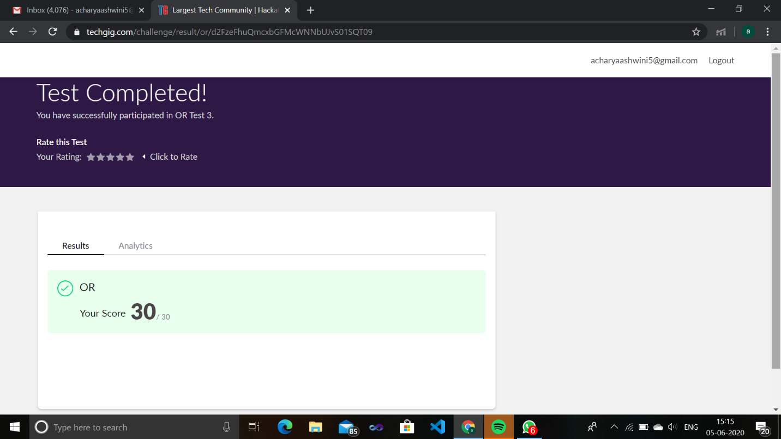CERTIFICATION COURSE:

**Introduction to Full Stack development:**

Today I have studied **Introduction to full stack developmengt:**



**Coding Challenges Details:**

1.Write a Java program to implement Circular Linked List Using Array And Class

**package** prog14;

**public** **class** CircularLinkedList {

**public** **int** size =0; **public** Node head=**null**; **public** Node tail=**null**;

//add a new node at the start of the linked list **public** **void** addNodeAtStart(**int** data){

System.***out***.println("Adding node " + data + " at start");

Node n = **new** Node(data); **if**(size==0){ head = n; tail = n;

n.next = head;

}**else**{

Node temp = head;

n.next = temp; head = n; tail.next = head;

} size++;

}

**public** **void** addNodeAtEnd(**int** data){ **if**(size==0){

addNodeAtStart(data);

}**else**{

Node n = **new** Node(data); tail.next =n; tail=n; tail.next = head; size++;

}

System.***out***.println("\nNode " + data + " is added at the end of the list"); }

**public** **void** deleteNodeFromStart(){

**if**(size==0){

System.***out***.println("\nList is Empty");

}**else**{

System.***out***.println("\ndeleting node " + head.data + " from start");

head = head.next; tail.next=head; size--;

}

}

**public** **int** elementAt(**int** index){ **if**(index>size){ **return** -1;

}

Node n = head; **while**(index-1!=0){ n=n.next; index--;

}

**return** n.data;

}

//print the linked list **public** **void** print(){

System.***out***.print("Circular Linked List:");

Node temp = head; **if**(size<=0){

System.***out***.print("List is empty");

}**else**{ **do** {

System.***out***.print(" " + temp.data); temp = temp.next;

}

**while**(temp!=head);

}

System.***out***.println();

}

//get Size **public** **int** getSize(){ **return** size;

}

**public** **static** **void** main(String[] args) {

CircularLinkedList c = **new** CircularLinkedList();

c.addNodeAtStart(3);

c.addNodeAtStart(2);

c.addNodeAtStart(1);

c.print();

c.deleteNodeFromStart();

c.print();

c.addNodeAtEnd(4);

c.print();

System.***out***.println("Size of linked list: "+ c.getSize());

System.***out***.println("Element at 2nd position: "+ c.elementAt(2));

}

}

**package** prog14;

**class** Node{ **int** data; Node next; **public** Node(**int** data){ **this**.data = data;

}

}

**Output:**

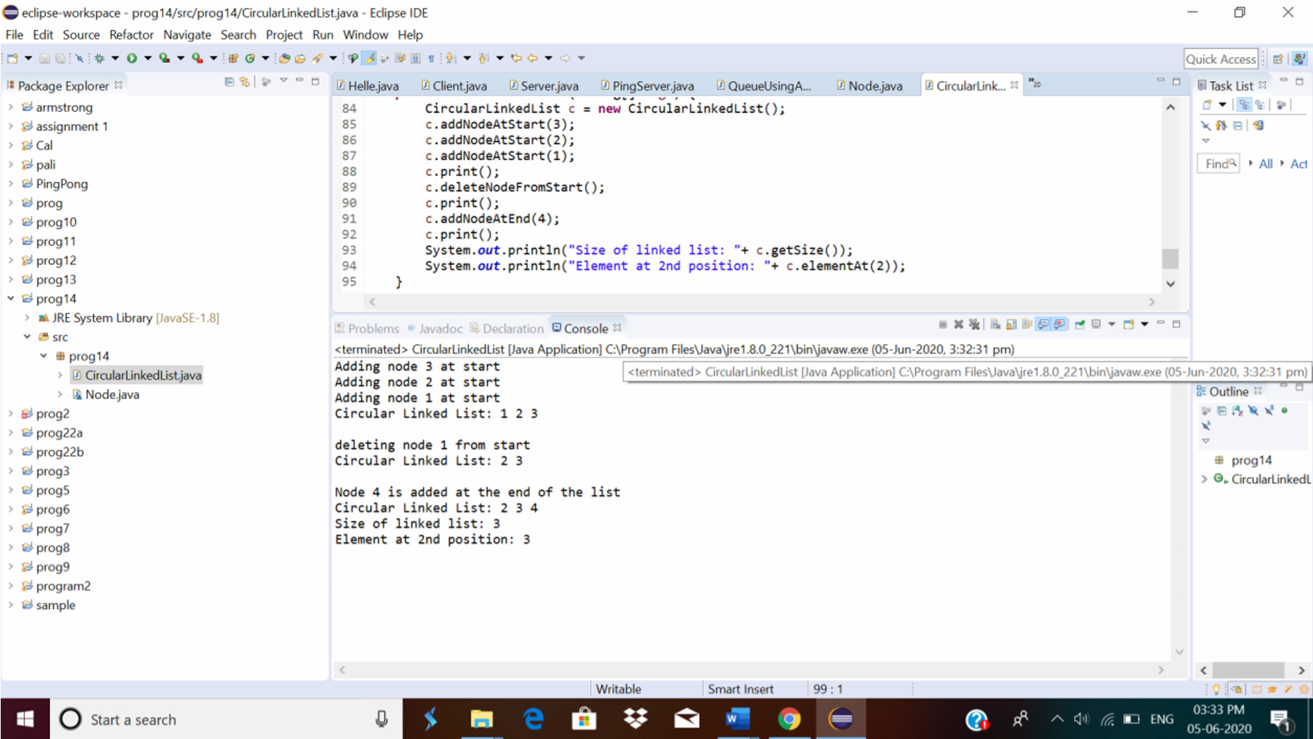

2.Python program to square each odd number in the list

Description:

Take a list of numbers and square each odd number in the list. Print output as comma separated sequence. eg:

input list: [2,4,5,6,7,8,9] output: 25,49,81

**Program:**

a=[2,4,5,6,7,8,9] print(a) print([i*i for i in a if(i%2!=0)]) **output:**

